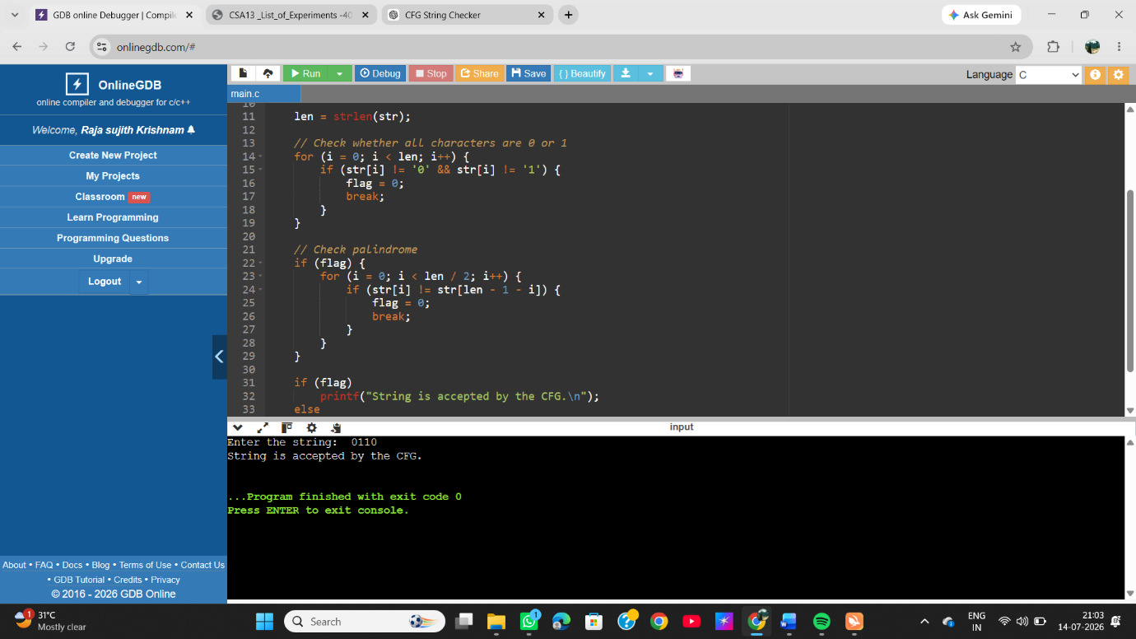
EXP 4 : Write a C program to check whether a given string belongs to the language defined by a Context Free Grammar (CFG) S → 0S0 | 1S1 | 0 | 1 | ε

